**Ideation Phase**

**Define the Problem Statements**

|  |  |
| --- | --- |
| Date | 26 May 2025 |
| Team ID | LTVIP2025TMID38840 |
| Project Name | Transforming Waste Management with Transfer Learning |
| Maximum Marks | 2 Marks |

**Customer Problem Statement Template:**

To build the right Cleantech solution, we must first understand our customers' real-world challenges. By focusing on the distinct problems of the Waste Facility Manager, the Municipal Director, and the Recycling Business Owner, we can create a system that solves their specific financial and operational issues, making their work more profitable and sustainable. By articulating their distinct problems, we can design an ideal Cleantech system that solves these specific financial, operational, and logistical challenges.

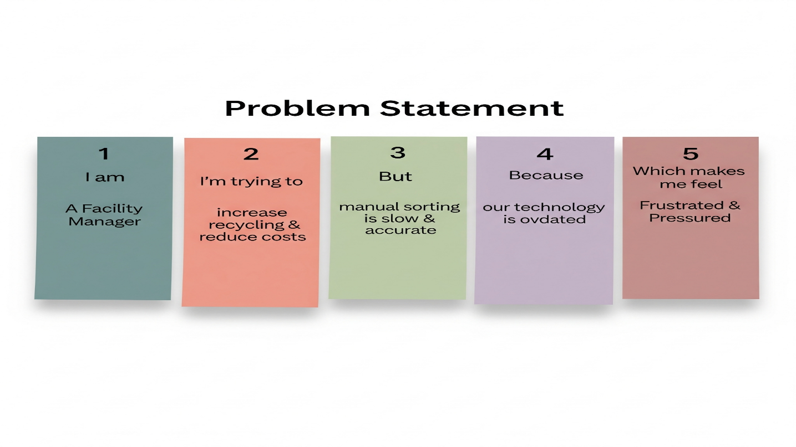**Example:**

|  |  |  |  |  |  |
| --- | --- | --- | --- | --- | --- |
| **Problem Statement (PS)** | **I am (Customer)** | **I’m trying to** | **But** | **Because** | **Which makes me feel** |
| PS-1 | A Waste Facility Manager in India | Increase recycling & reduce costs | Manual sorting is slow, inaccurate, and contaminates materials. | Our technology is too old for modern, complex waste. | Frustrated & Pressured |
| PS-2 | A Municipal Director | Adopt innovative technology for our city | New AI systems seem too expensive and complex to implement. | The required investment is high, and my team lacks the skills. | Sceptical & Hesitant |
| PS-3 | A Recycling Business Owner | Source a consistent supply of pure, recyclable material | The material I purchase from the facility is often contaminated | The facility's manual sorting process cannot guarantee purity. | Worried about my supply chain and business viability. |